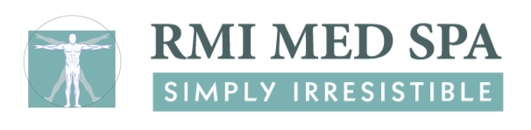

Microdermabrasion and Dermaplaning
Consent Form

DIAMONDTOME Microdermabrasion uses a diamond encrusted wand to remove superficial layers of the skin in the areas treated. The intensity of the procedure can be adjusted to your desired results and comfort level. Microdermabrasion is often used to treat acne, reduce the appearance of scars, wrinkles, hyperpigmentation and other skin conditions. A series of treatments is recommended for maximal results.

Dermaplaning uses a blade to gently exfoliate the outer layer of dead skin cells and remove fine facial hair commonly known as "peach fuzz". This procedure produces an immediately more radiant appearance. Following this treatment, makeup application is smoother and other skin products penetrate deeper making them more effective. A series of treatments is recommended for maximal results.

After a treatment skin may feel tight and warm as if exposed to the sun or wind but this should resolve within 24 hours. Slight redness and swelling might appear with more intensive treatments and take several days to resolve.

Your fresh, newly exposed skin will be delicate. It is important that you use a mild basic cleanser and keep the skin well moisturized particularly around the delicate eye area. You should use a full spectrum sunblock daily. We recommend a physical sunblock containing zinc as it is less irritating to sensitive skin. Avoid the use of Retin-A, Renova, alpha or beta hydroxyl acid products and all forms of scrubs for at least 24 hours after a treatment. Avoid swimming and tanning beds for at least one week.

Anytime the skin barrier is broken, there is a small risk of bacterial or viral infection.

I acknowledge that no guarantee has been given regarding the condition of my skin or the percentage of improvement expected following treatment. I understand that no specific results are guaranteed.

My signature below acknowledgement that I have read and understand the foregoing informed consent and agree to the treatment with its associated risks.

I hereby give consent to perform a microdermabrasion treatment. I agree to hold harmless RMI Med Spa for any adverse reactions due to omitted information and/or misinformation on the Skin Health Questionnaire and/or from actions which deviate from pre- and post-care procedures.

____________________________________
Print Patient Name

___________________________________ _____________________
Patient Signature Date

____________________________________ ____________________
Witness Date

Please call 941-266-9090 with any questions or concerns.

Tamara L. Densmore, M.D., Medical Director
100 North Washington Blvd., Suite 102, Sarasota, FL 34236
office: 941-266-9090 fax: 941-718-4920 www.rmimedspa.com

