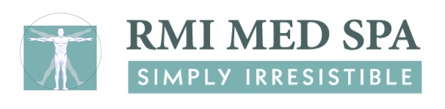
Chemical Peel
Pre Treatment Instructions

- Avoid the following for seven (7) days prior to a Chemical Peel:
  - Botox injections
  - Filler injections
  - Retin-A, Renova, and all products containing hydroxy or glycolic acid products

- A Chemical Peel may cause a flare-up of the Herpes Simplex virus in patients prone to cold sores. You should see my physician regarding a preventative anti-viral prescription if you are prone to Herpetic outbreaks (cold sores/fever blisters.)

- A Chemical Peel is not recommended if you are currently taking or have taken Accutane in the past 12 months.

- If you have any of the following conditions in the area you are considering having treated, you should NOT undergo a Chemical Peel:
  - Impetigo
  - Inflamed eczema
  - Herpes simplex (also known as cold sores or fever blisters)
  - Undiagnosed skin lesions
  - Sunburn.

Please call 941-266-9090 with any questions or concerns.

Tamara L. Densmore, M.D., Medical Director
100 North Washington Blvd., Suite 102, Sarasota, FL 34236
office: 941-266-9090 fax: 941-718-4920 www.rmimedspa.com

